Study of HTTP-Connectivity-Tester

Lu Lin, CPSC 6126

Columbus State University

From the National Security Agency’s Open Source Software Site [1], I choose the application HTTP-Connectivity-Tester from NSA Cybersecurity site, this tool can aid in discovering HTTP and HTTPS connectivity issues. Before using this tool, I download the repository from Official GitHub for NSA’s Cybersecurity [2], configure the PowerShell environment, extract and load code, and then run the code (as Figure 1). In order to conduct the case reserach, I choose a service/product named “WindowsTelemetry” from the vendor Microsoft to run, view, and save the connectivity test.

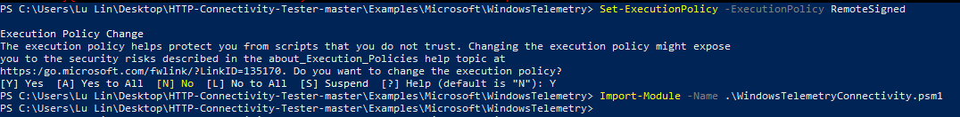

Figure 1. Configuration

The main Get command will return a Connectivity object that contains information about the connectivity test. This object provides data that can help determine if a URL or service is blocked and The Connectivity object can be saved to a JSON file using the Save-HttpConnectivity command from the PowerShell module. I attach my connectivity testing result in JSON file as part of the lab submission.

From testing result we can see there are twelve TestUrl, which is the URL used to perform the test. Under TestUrl there is “Description” which describes what the URL is for, such as:



Figure 2. Description

In this test all TestUrl have “Blocked” value of false, which means these services appear not to be blocked. “IpAddresses” is a list of IP addresses corresponding to the TestUrl. “ExpectedStatusCode” is the expected HTTP status code returned by the test, while “ActualStatusCode” is the actual HTTP status code returned by the test (When Blocked is true this value will be 0). There is properties “ServerCertificate” that can help determine if the connection failure is the result of certificates, as shown in Figure 2. For example, “ServerCertificate.HasError” shows whether there is a generic TLS error, in this testing case the values are all false. And “ServerCertificate.HasValidationError” shows whether there is a TLS error related to certificate validation, and in this testing case the values are all false.

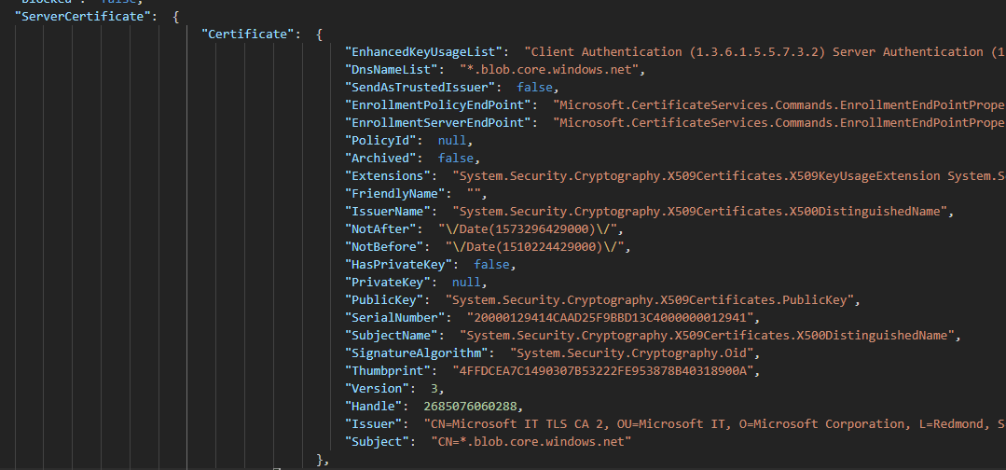

Figure 3. ServerCertificate

References:

1. <https://code.nsa.gov/>
2. <https://github.com/nsacyber/HTTP-Connectivity-Tester>